* 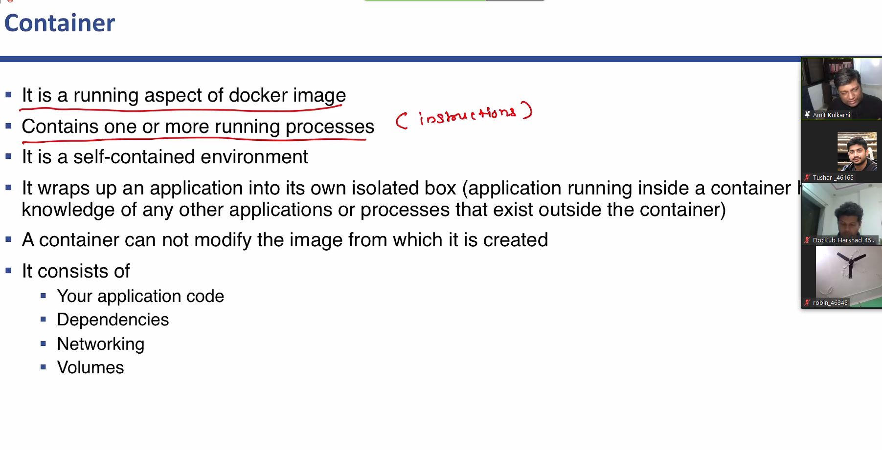
* Containers are immutable.
* When it is deleted we cannot change anything on containers.
* Containers cannot save data on its own, it will need a volume.
* Container will just execute the program.

docker container run--name mycontainer hello-world

- create a container with user given name

docker container run --name mycontainer --rm hello-world

-anticlimactically delete a container while creaking

* A writeable layer can be added or deleted to the container
* By default containers are linux containers
* Container user linux kernel
* Container name should be unique

docker container run --name ubuntu ubuntu date

-overite the command with the date command

docker container run --name ubuntu -it ubuntu

-to get interactive access to the container (-it is interactive teletype)

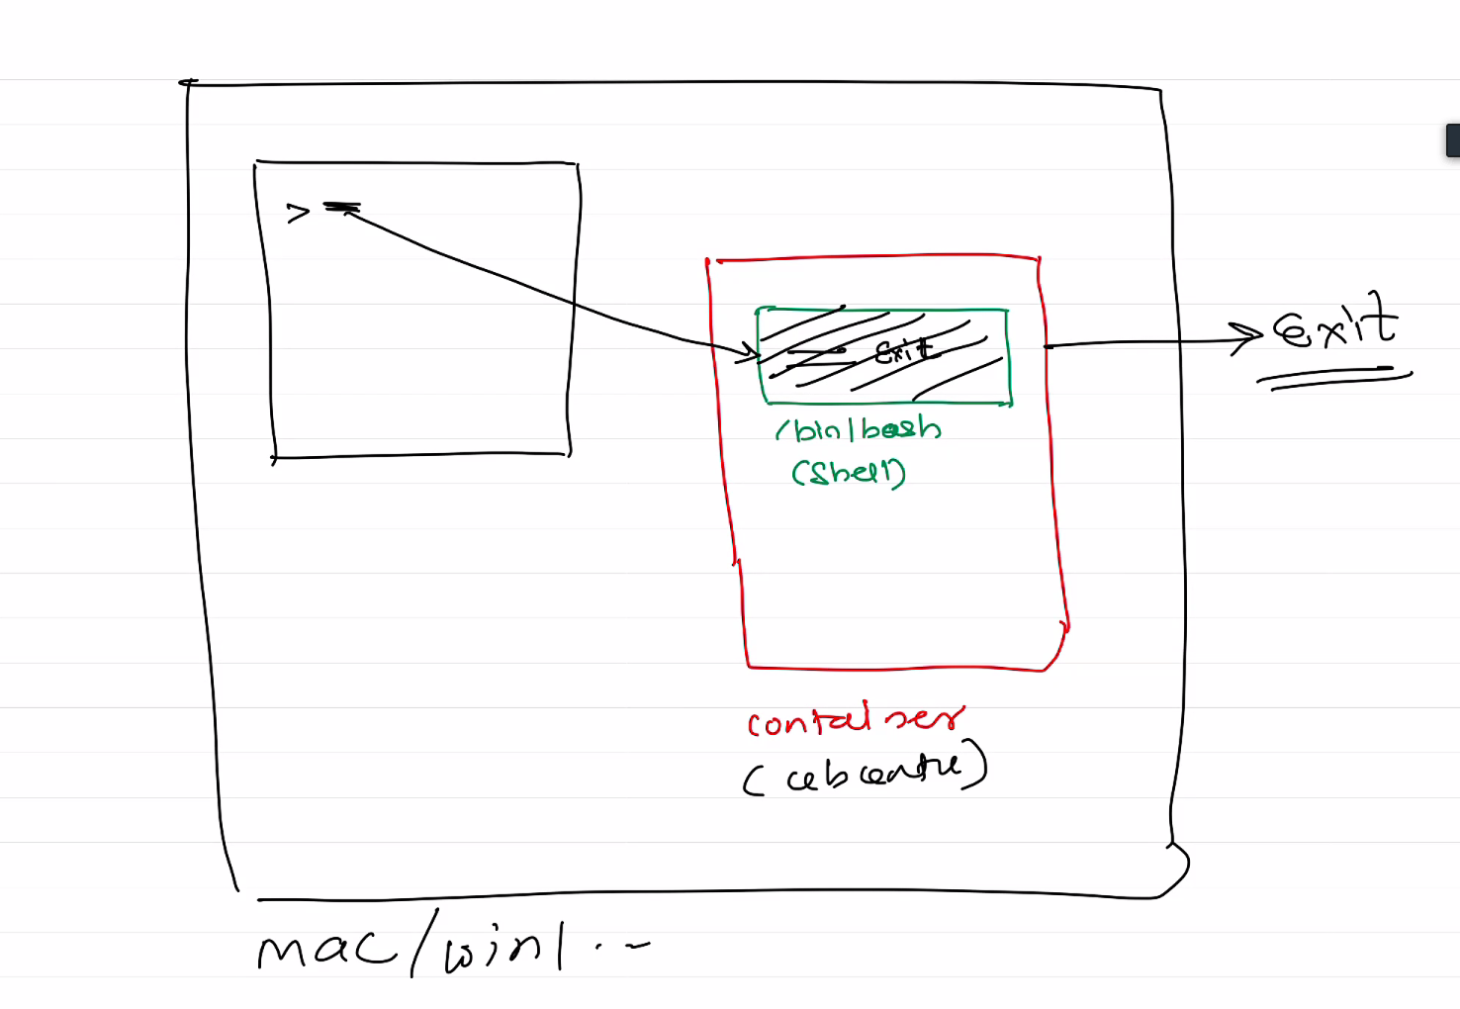

Docker container exec <command>

-run the command in the container from outside.

Docker container attach <container_name>

-attach your terminal to the container bash(after we exit this container with exit)

***Difference b/w attach and exec***

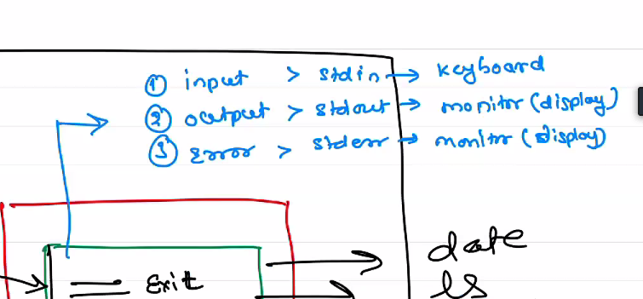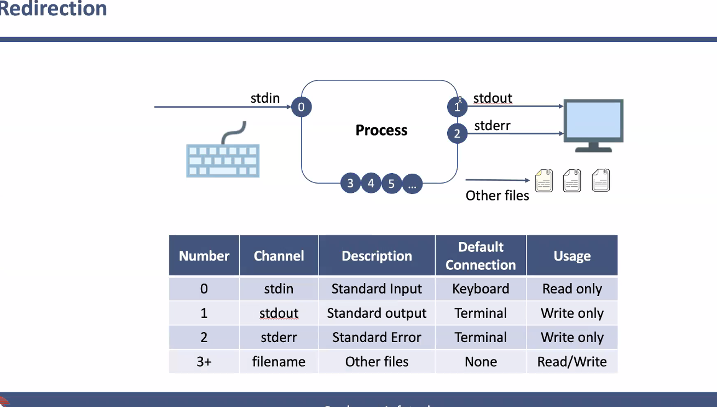

docker container exec -it ubuntu bash

docker container exec -it ubuntu bin/bash

-this will spawn a new bash within the bash of the container to use it.

-with this we can avoid exiting the main process/container and while exiting we just exit the forked process.

* Forking happens only in dettached mode, can be used in exec

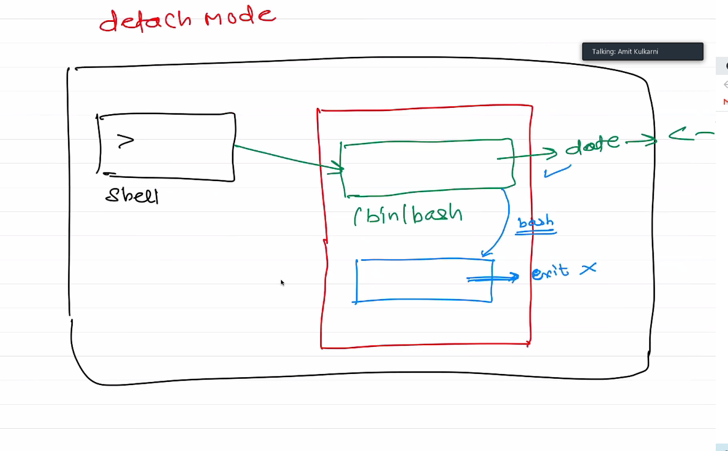

- Attach(attach mode) will be attaching the main process but exec(dettached mode) will connect us to child spawn bash/process.

- Exiting attach will exit from main process therefore from contianer but Exiting exec will exit us from spawned bash/process not the parent bash.

- Parent bash is like init method here for all the other bashes

docker container run -it ubuntu

- it is by default attach mode

docker container run -itd ubuntu

- this will run bash in dettached mode.

docker container run -itd --name ubuntu ubuntu

docker container run -itd --name mysql -e MYSQL_ROOT_PASSWORD=root mysql

- MYSql command to pull image and start the container